Lab 3 Report:

Objectives:

1. To get familiar with online simulator
2. To build and simulate basic DC circuits with simulator
3. To calculate the voltage of a circuit with Kirchhoff’s Voltage Law
4. To calculate the voltage of a circuit with Kirchhoff’s Current Law

Part I: Kirchhoff's Voltage Law:

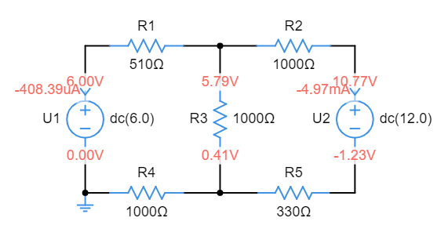

Table 1. Loop-1 Voltage

| Voltage (V) |  |  |  |  |  |
| --- | --- | --- | --- | --- | --- |
| Calculation | 0.21 | 5.38 | 0.41 | -6 | 0 |
| Simulation | 0.21 | 5.38 | 0.41 | -6 | 0 |

Table 2. Loop-2 Voltage

| Voltage (V) |  |  |  |  |  |
| --- | --- | --- | --- | --- | --- |
| Calculation | -4.97 | 12 | -1.64 | -5.38 | 0.01 |
| Simulation | -4.98 | 12 | -1.64 | -5.38 | 0 |

Mathematical analysis and calculation: (All answers are corr. to 2 decimal places)

Loop 1:

Loop 2:

Part II: Kirchhoff’s Current Law

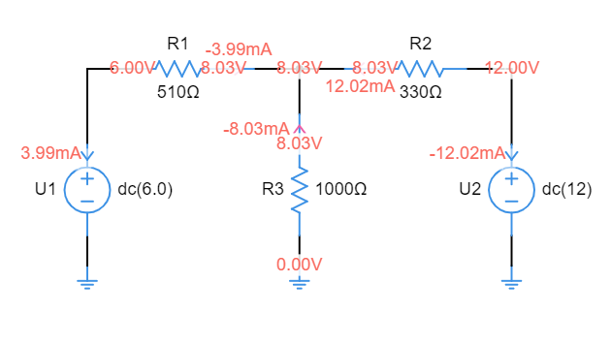

Table III

| Current(mA) |  |  |  |  |
| --- | --- | --- | --- | --- |
| Calculation | -3.99 | 12.02 | -8.03 | 0 |
| Simulation | -3.99 | 12.02 | -8.03 | 0 |

Mathematical analysis and calculation: (All answer are corr. to 2 decimal places)

Discussion:

1. Since the voltmeter has an internal resistance, and we may normally ignore this in the calculation and simulation. In reality, when we connect the voltmeter in parallel with the resistor, the measured voltage will be the parallel combination of the resistor and the voltmeter. For example, if the difference between the internal resistance of the voltmeter and the resistance of the resistor is relatively large, the error can be negligible. However, if the difference between them is not that large, then the internal resistance of the voltmeter may steal the current from the resistor and make the measured voltage inaccurate. Therefore, the measured voltage will be practically lower than the calculations and simulations
2. If we consider the internal resistance of the voltage sources. In that case, the voltage source no longer can provide constant and steady voltage to the whole circuit as the internal resistance may absorb some power in the voltage source. Also, by using V=IR, the value of R is larger when the internal resistance is considered. Therefore, the current provided to the circuit will be lower in this case.

Conclusion:

To conclude, through the simulation and calculation of the lab, we can know that KCL and KVL are useful for us to analysis the circuit, and it is always true that the sum of the voltage around a loop must equal zero and the sum of the currents at a node must equal to zero. Also, we usually consider the circuit element in an ideal case for simpler calculation for the calculation and simulation. However, in reality, many circuit elements such as the voltage source, current source, voltmeter, and ammeters that consist of internal resistance that may lead to the actual result and the measured value are not the same as we calculated or expected.